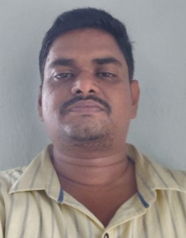

Profile
- Name : G.D.SRINIVASA REDDY
- Designation : LECTURER IN PHYSICS
- Date of Birth : 25-08-1985
- Educational Qualifications : M.Sc PHYSICS .B.Ed,.
- Teaching experience : 13 YEARS
- Research Experience : NIL
- Dissertation/Thesis Title : NIL
- No. of Research publications : NIL
- No. of Books Published : NIL
- No. of Major/Minor Research Projects: NIL
- Title of Minor Research Project : NIL
- No .of International Conferences Attended : NIL
- No. of National Conferences Attended : NIL
- No. of Papers Presented at the Seminars/Conferences: NIL
- Refresher Courses/Orientation Programs/Training Programs Attended: NIL
- Vidwaan Score : NIL
- Address : G.D.SRINIVASA REDDY , S/O G.ADINARAYANA REDDY MARTERU , WEST GODAVARI 534122

- E-mail Id : dreams.gd@gmail.com
- Contact no : 8801835321

